**IST 722 Final Project: ETL DOCUMENTATION**

**GROUP 3F**

**Date: December 3rd 2020**

**1. ETL of Date Data:**

The below screenshot shows the control flow for the date dimension. It contains the SQL truncate and two dataflows.

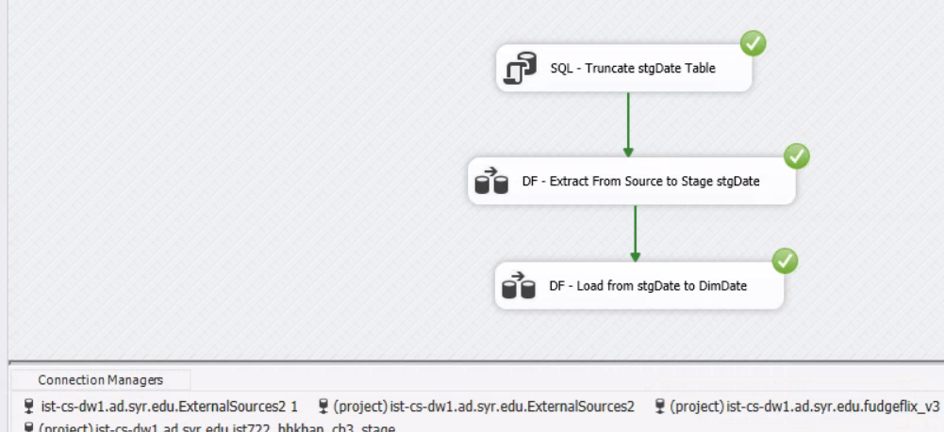

**1.1 Staging of Date Data**

The below screenshot shows the dialog flow for the source to stage process for the Date Dimension. It contains a source assistant and a destination assistant.

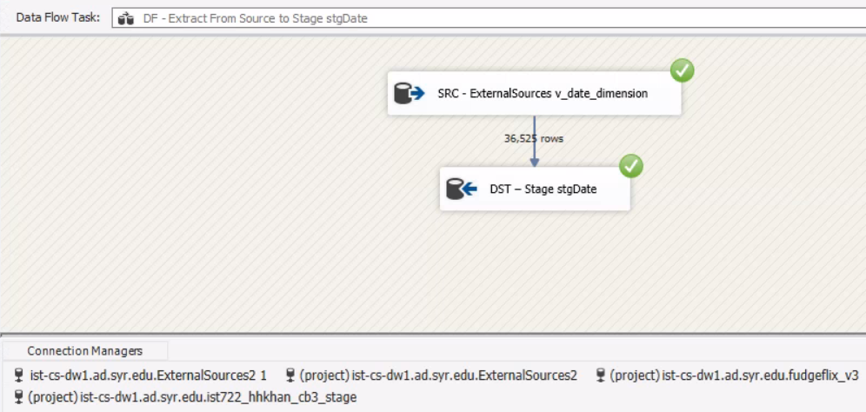

**1.2 Loading of Date Data**

The below screenshot shows the dataflow for the stage to warehouse process for the Date Dimension. It contains a source assistant and a destination assistant.

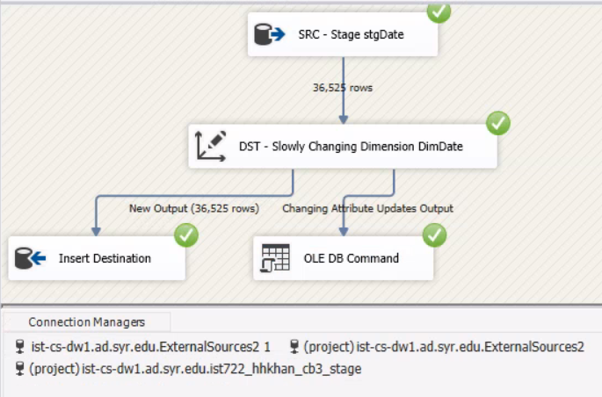

**2. ETL of Fudgemart Data:**

The below screenshot shows the control flow for the source to stage process. It contains the SQL truncate and three dataflows.

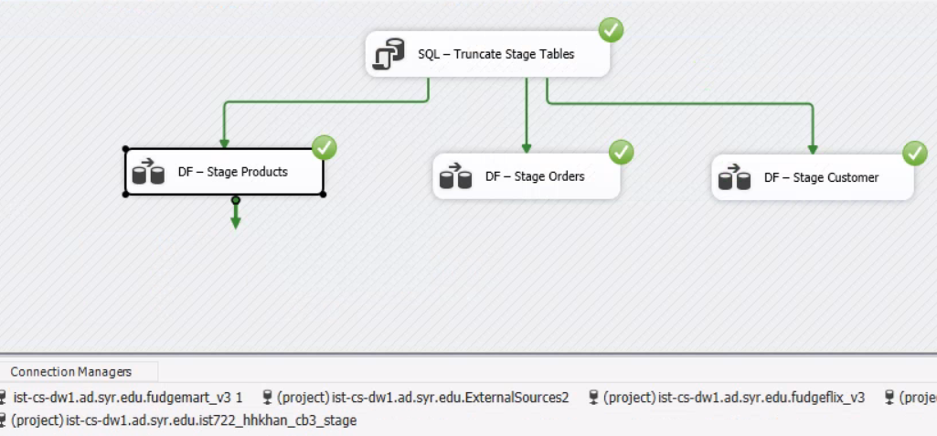

**2.1 Staging of Product Data**

The below screenshot shows the dialog flow for the Product Dimension source to staging process. It contains a source assistant and a destination assistant.

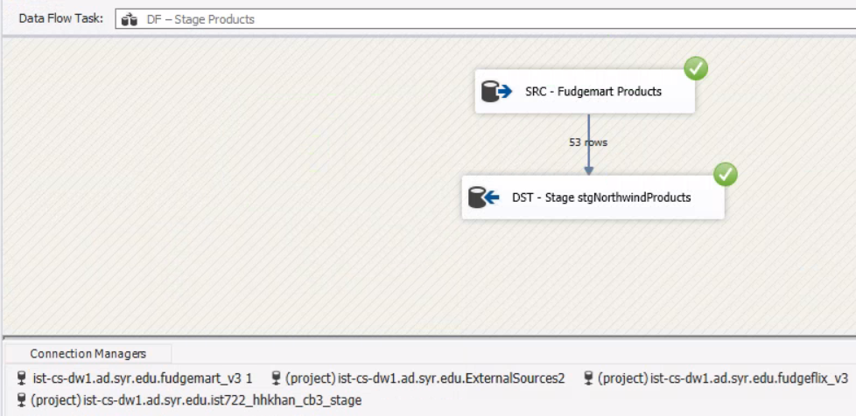

**2.2 Staging of Order Data**

The below screenshot shows the dialog flow for the Order Dimension source to staging process. It contains a source assistant and a destination assistant.

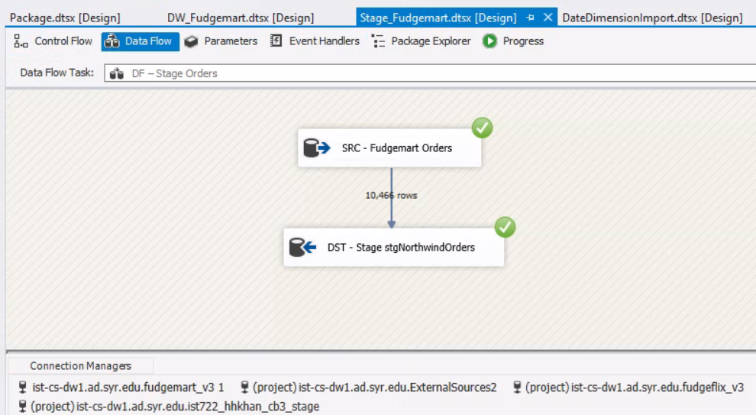

**2.3 Staging of Customer Data**

The below screenshot shows the dialog flow for the Customer Dimension source to staging process. It contains a source assistant and a destination assistant.

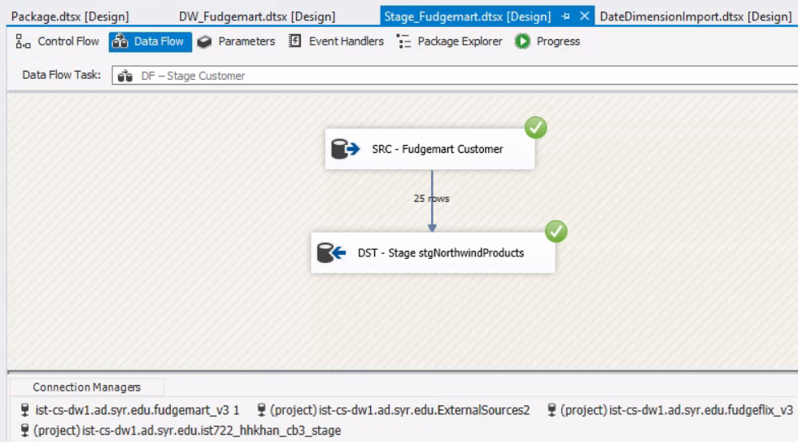

The below screenshot shows the control flow for the stage to warehouse process for the Customer and Product dimensions as well as the Fact Table. It consists of three DataFlows.

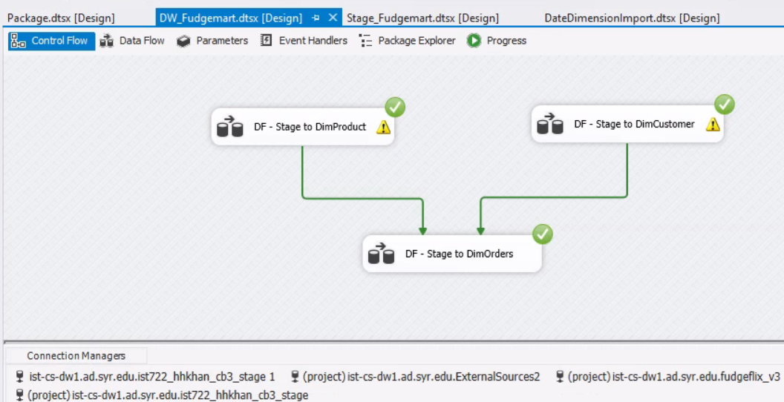

**2.4 Loading of Product Data**

The below 2 screenshots show the dialog flow for the Product Dimension stage to warehouse ETL process. It consists of a source assistant, a derived column and a slowly changing dimension.

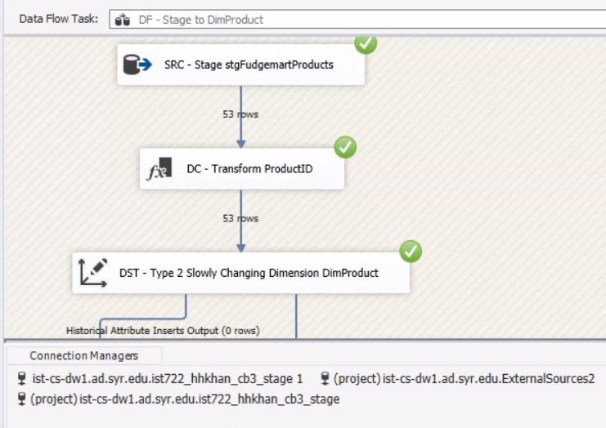

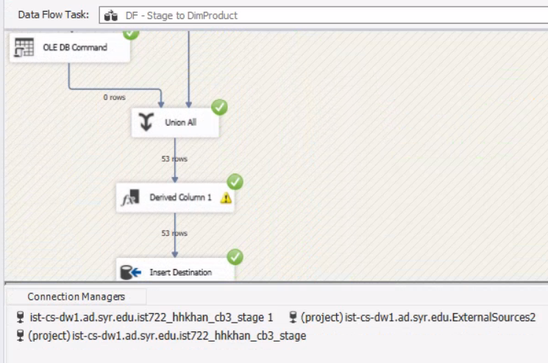

**2.5 Loading of Customer Data**

The below 2 screenshots show the dialog flow for the Customer Dimension stage to warehouse ETL process. It consists of a source assistant, a derived column and a slowly changing dimension.

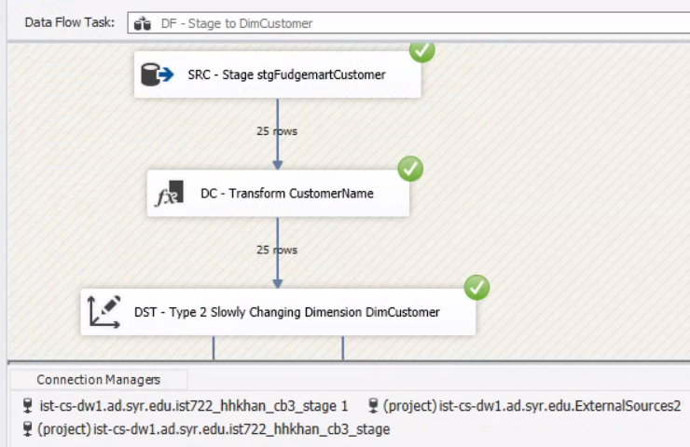

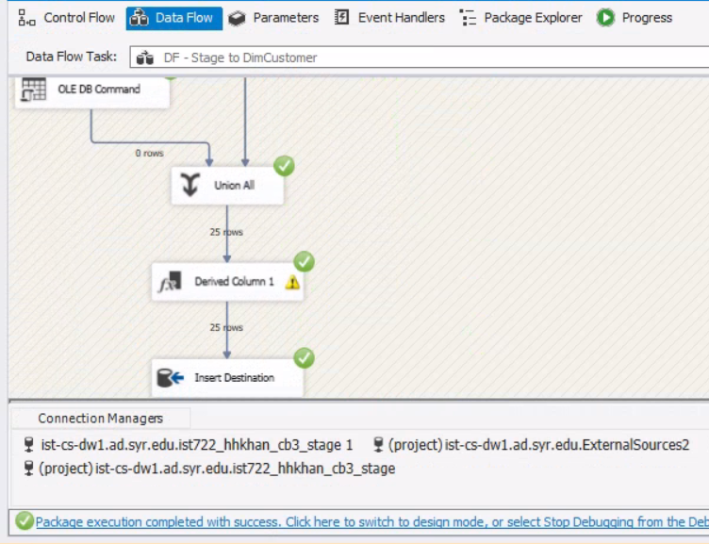

**2.6 Loading of Order Data**

The below 3 screenshots show the dialog flow for the Order Dimension stage to warehouse ETL process. It consists of a source assistant, a derived column, four lookups and a slowly changing dimension.

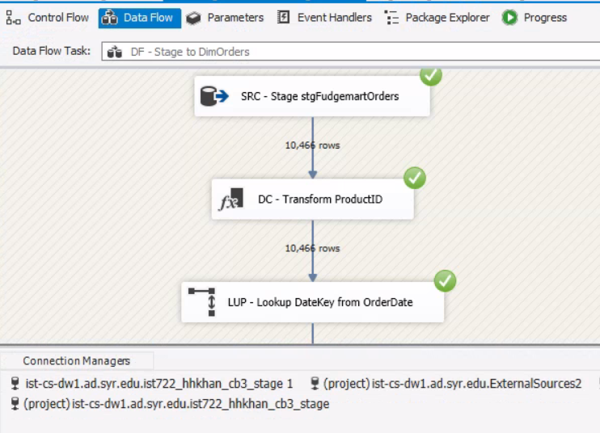

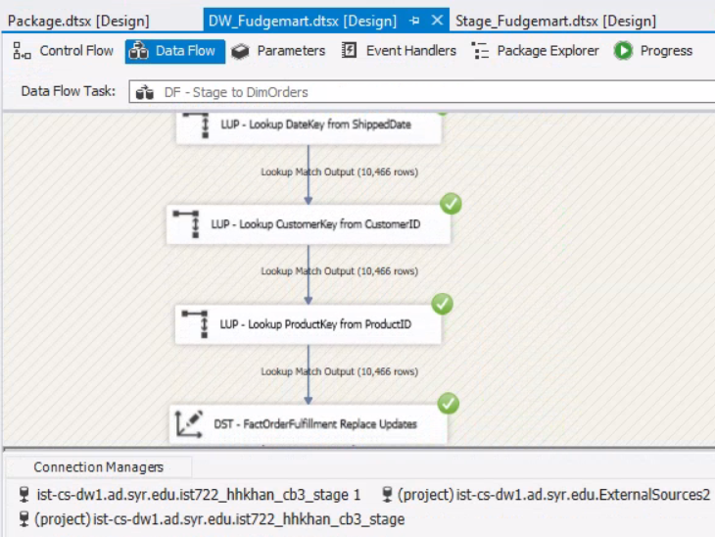

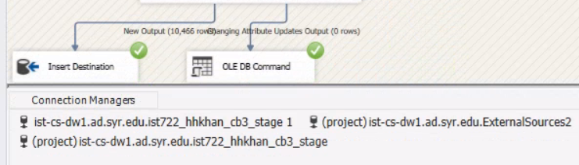

**3. ETL of FUDGEFLIX Data**

**3.1 Staging of FUDGEFLIX Data**

The below **Control Flow** imageshows the Data being extracted from the OLTP source which is FudgeFlix in this case to the Stage database. The Control Flow contains the SQL Truncate task and 3 Data Flows as shown below.

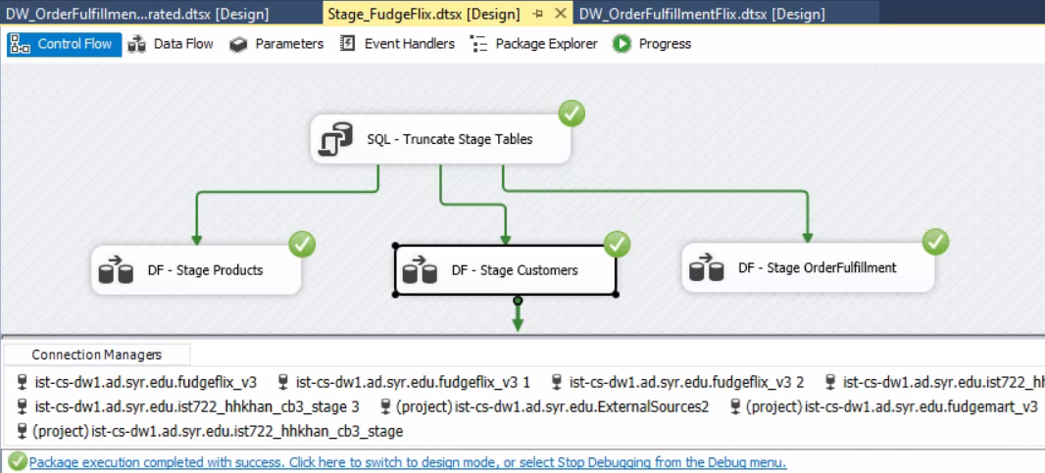

**3.1.1 Data Flow of Staging FudgeFlix Products (For Product Dimension Table)**

The first data flow task of this staging control flow is as shown below. It involves extraction of data from the FudgeFlix <“ff_titles”> table into the Products Stage table.

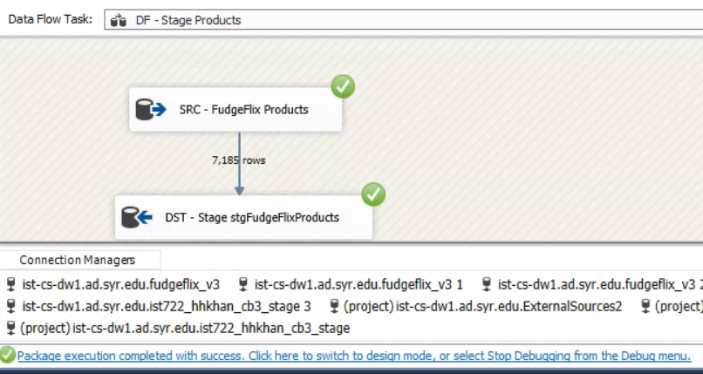

**3.1.2 Data Flow of Staging FudgeFlix Customers (For Customer Dimension Table)**

The second data flow task of this control flow is as shown below. It involves extraction of data from the FudgeFlix <“ff_accounts”> table into the Customers Stage table.

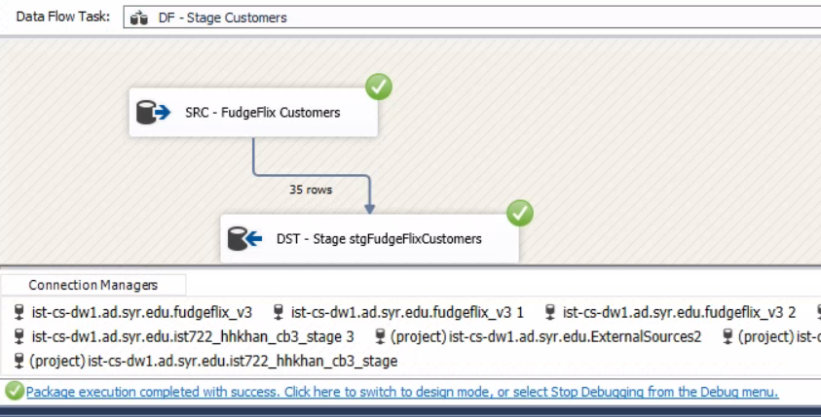

**3.1.3 Data Flow of Staging FudgeFlix Orders (For Order Fulfillment Fact Table)**

The third data flow task of this control flow is as shown below. It involves extraction of data from the FudgeFlix <“ff_account_titles”> table into the Order Fulfillment Stage table.

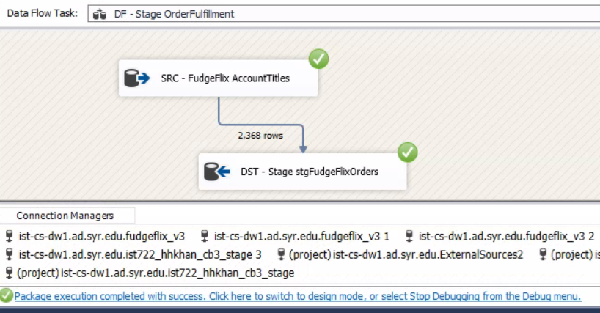

**3.2 Loading FUDGEFLIX Data from Stage to the Data Warehouse**

The below **Control Flow** imageshows the Data being pulled from the FudgeFlix Stage database and loaded into the integrated Data Warehouse. The Control Flow contains the 3 Data Flows as shown below.

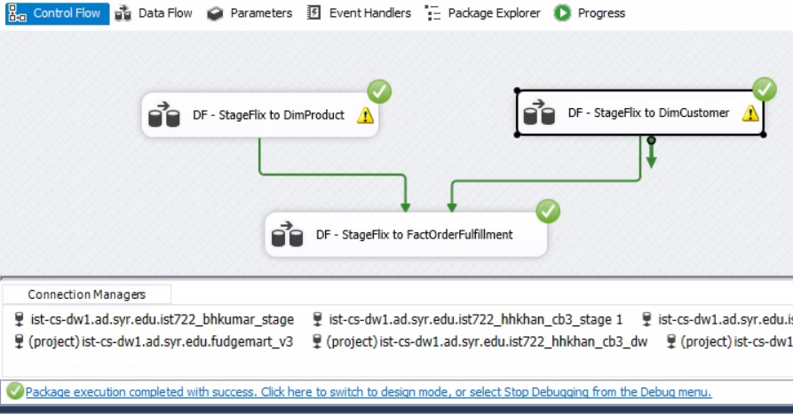

**3.2.1 Data Flow of Loading Staged FudgeFlix Products to Product Dimension Table of Data Warehouse**

The first data flow task of this control flow is as shown below. It involves Loading of data from the FudgeFlix Products Stage table into the Product Dimension table of the Data Warehouse.

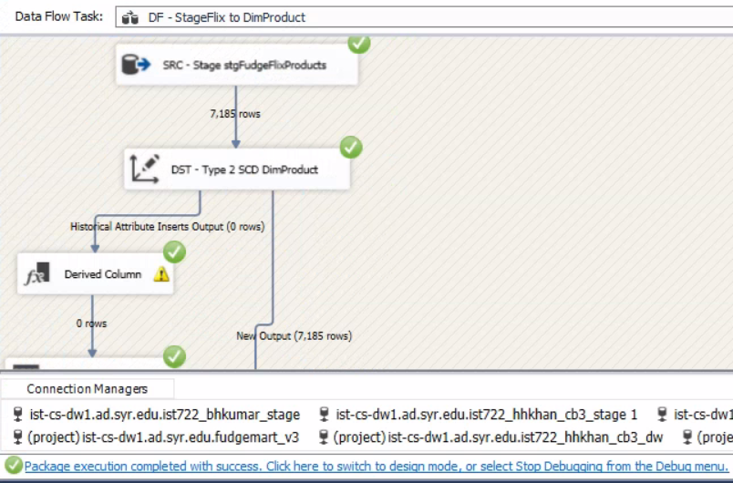

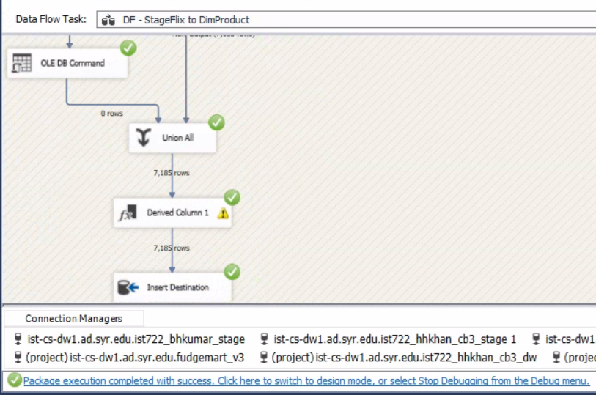

**3.2.2 Data Flow of Loading Staged FudgeFlix Customers to Customer Dimension Table of Data Warehouse**

The second data flow task of this control flow is as shown below. It involves Loading of data from the FudgeFlix Customers Stage table into the Customer Dimension table of the Data Warehouse.

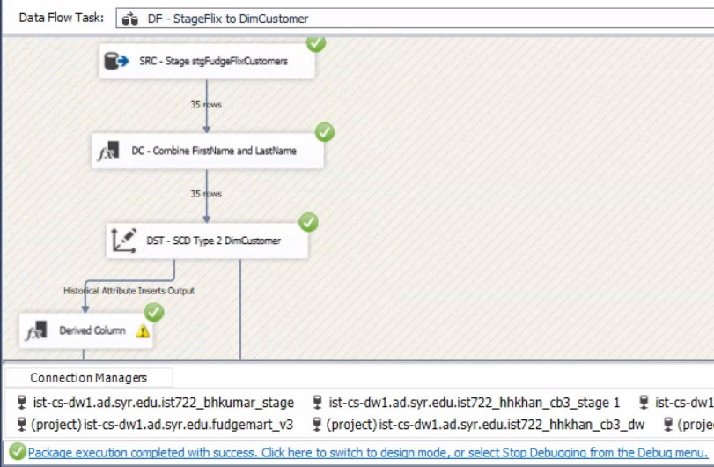

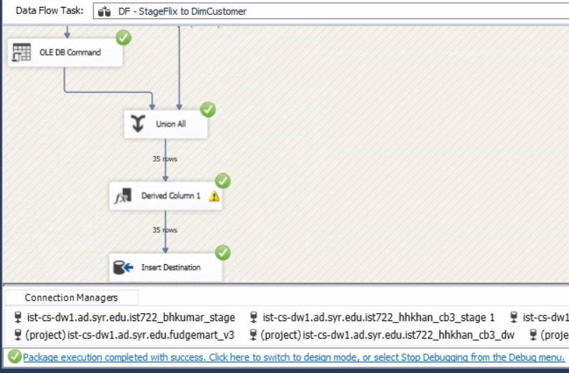

**3.2.3 Data Flow of Loading Staged FudgeFlix Orders to Order Fulfillment Fact Table of Data Warehouse**

The third data flow task of this control flow is as shown below. It involves Loading of data from the FudgeFlix OrderFulfillment Stage table into the Fact table of the Data Warehouse.

